 | 19.3.2 Editors - Drivers Editor - Sidebar - Drivers Tab
Table of content
Driven Property Panel 2
Driver Panel 2
Type 2
Built in functions 2
Scripted Expression 2
Expression 2
Use Self 2
Add Input Variable 3
Copy Driver variable 3
Paste Driver variable 3
Driver variable panel 3
Variable type 3
Single Property 3
Prop 3
Type 3
ID 4
Path 4
Setting up by hand 4
Setting up by Copy as New Driver 4
Value 5
Transform Channel 5
Type 5
Rotation Mode 5
Transform space 6
World Space 6
Transform Space 6
Local Space 6
Value 6
Rotational Difference 6
Object 1 6
Bone Name 6
Object 2 6
Value 6
Distance 6
Object 1 6
Bone Name 6
Transform space 6
World Space 6
Transform Space 7
Local Space 7
Object 2 7
Transform space 7
World Space 7
Transform Space 7
Local Space 7
Value 7
Variable name 7
Delete Target Variable 7
Update Dependencies 7

Driven Property Panel
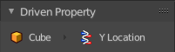
This panel displays the driven property of the object. It is read only.
Note that you need to have a channel selected to show the tabs.

Driver Panel

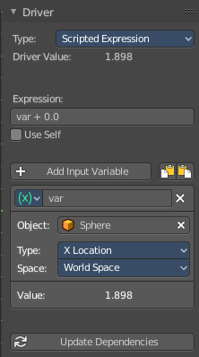
The actual driver with all its settings.

Type

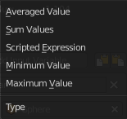
Built in functions
Average, Sum, Min and Max are Built-In functions. The driven property will have the value of the average, sum, lowest or highest values of the referenced driver variables. Remember that you can add more than one input variable. So when you for example use the X position of two cubes as the input, and the method Average, then the driven object will be located at the average X value of cube 1 and cube 2.
When there is just one Input variable, then the driven object will be positioned at the value of the driver object.

Scripted Expression
Allows you to use Python expressions that can refer to the driver variables by name. An expression allows you to use standard constants and math functions.

Expression
A text field with the current expression. Not available with all variable types.

Use Self
The variable Self can be used for drivers to reference their own data. Example:
self.location.x applied to the Y rotation property of the same object will make the object tumble when moving.
Note that dependencies for properties accessed via self may not be fully tracked.

Add Input Variable
Adds a new driver variable.

Copy Driver variable
Copies the driver variable.

Paste Driver variable
Pastes a copied driver variable.

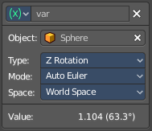
Driver variable panel

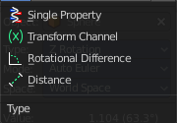
Variable type
The type of variable to use.

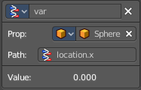
Single Property
Allows you to retrieve a single value of a RNA Property, specified by a data block reference ( the source object) and a path string ( the property of this source object).

Prop

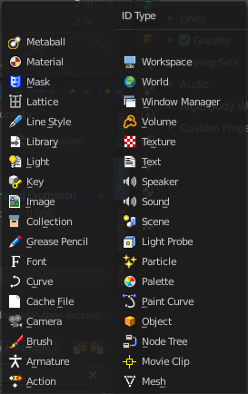
Type
Define the input type of the object. You can retrieve values from nearly every object type.

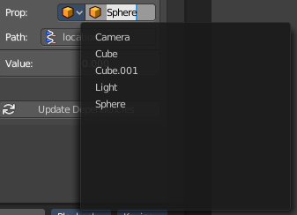
ID
The source object. This is also a drop down field where you can pick objects from the scene.

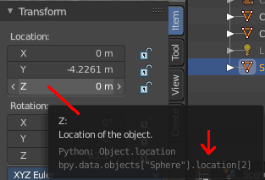
Path
The path string to use. This defines the property where you get the value from.

Setting up by hand
Have a look at the python tool tip in the property of the source object. The bpy.data string gives you a hint of the expression that you need.
For example, if i want to use the Z location of the sphere as the driver value.
The python string in the tool tip of the Z location property says
bpy.data.objects["Sphere"].location[2]
The sphere is already chosen as the source object. Remains the part behind objects["Sphere"] in the string.
location[2]
To use location[2] in the path will already work. But you can point directly to the single axis too. The tool tip uses an array for the axis. 0 for X, 1 for Y and 2 for Z. When you want to use the axis letters, then you need a dot between location and the axis letter. And so the other working string is:
location.z

Setting up by Copy as New Driver
The easier way is to right click at the value that you want to use as the driver value. Here choose Copy as new Driver. In the target property choose Paste Driver. And this creates a driver with the correct values then that contains all relevant settings.
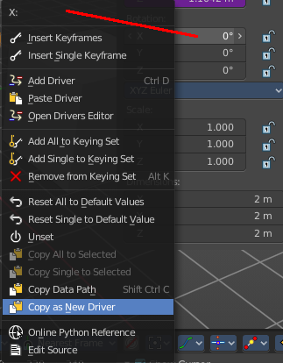
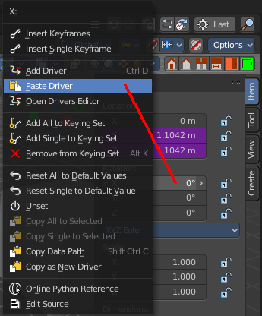
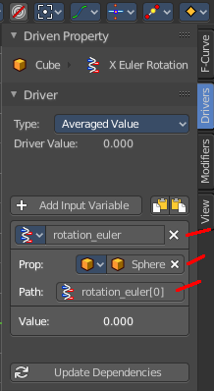

Value
The result of the diver variable. Read only.

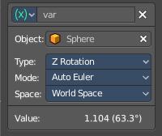
Transform Channel
Uses the transform values of the source object.

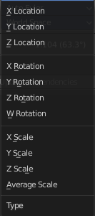
Type
The transform type.

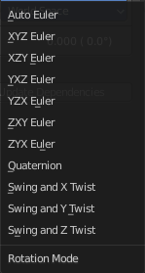
Rotation Mode
Just for Rotation transformations. The rotation mode.

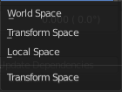
Transform space
In which transform space the transformation should happen.

World Space
Transforms includes effect of parenting / restpose and constraints.

Transform Space
Transforms don't include effect of parenting / restpose and constraints.

Local Space
Transforms include constraints, but not effect of parenting / restpose.

Value
The result of the diver variable. Read only.

Rotational Difference
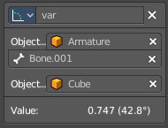
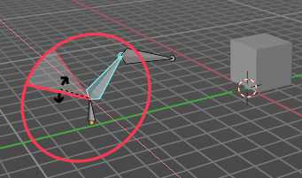
Use the angle between two bones. The parent bone acts as the second bone here.

Object 1
The source armature.

Bone Name
The source bone of this armature.

Object 2
The target object.

Value
The result of the diver variable. Read only.

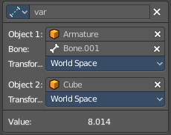
Distance
The distance between two bones or objects is used for the driver.

Object 1
The source armature.

Bone Name
The source bone of this armature.

Transform space
In which transform space the transformation should happen.

World Space
Transforms includes effect of parenting / restpose and constraints.

Transform Space
Transforms don't include effect of parenting / restpose and constraints.

Local Space
Transforms include constraints, but not effect of parenting / restpose.

Object 2
The target object.

Transform space
In which transform space the transformation should happen.

World Space
Transforms includes effect of parenting / restpose and constraints.

Transform Space
Transforms don't include effect of parenting / restpose and constraints.

Local Space
Transforms include constraints, but not effect of parenting / restpose.

Value
The result of the diver variable. Read only.

Variable name
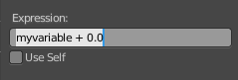
The name of the variable. This name of the variable is used for calculation in the expression. This variable can be renamed. Make sure to update the name of the variable in the expression then too.

Delete Target Variable
Removes the variable.

Update Dependencies
Some changes may not update automatically. Update dependencies updates all the changes done to the drivers.

